Computer Language Coding Concepts

Command References in a Command Definition in a Diagram
This article demonstrates a situation of command objects.

This article illustrates how command references in a command definition look in a diagram.

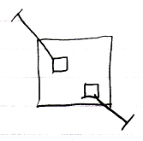

The larger square is a command definition. The smaller square inside them are command references in a command definition. They are actually public command references. This makes the command references parameters of the command definition. The command references have object lines, solid ones, going outside, ending at an access mark. Those object lines are indications of parameter passing, indicating that the command references are so called Reference parameters. Parameter passings are explained in the parameter articles.

See also: Commands, Parameters

Author & Copyright: Jan-Joost van Zon Date: August 9, 2008 – August 23, 2008 Location: Oosterhout, The Netherlands Status: Finished

